**Celebrate Lunar New Year 2020 In Europe With Journey 10N9Đ**

*Attention:*

-Departure point: Hanoi.

-Time: 10 days 9 nights.

-Media: aircraft.

-Price: 59900000đ.

-Picture:

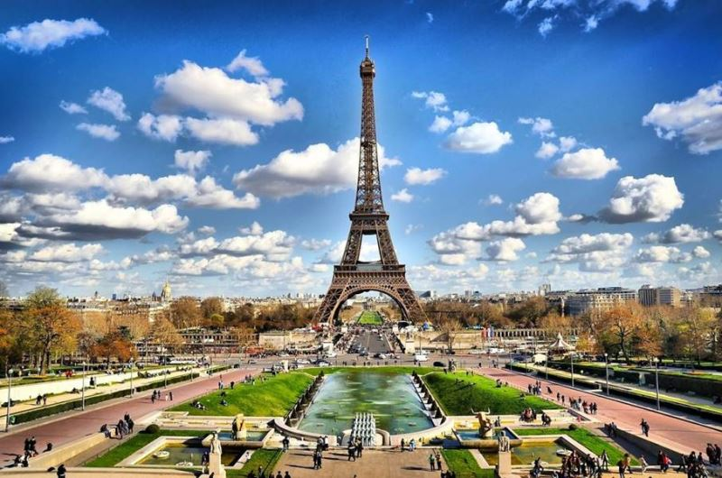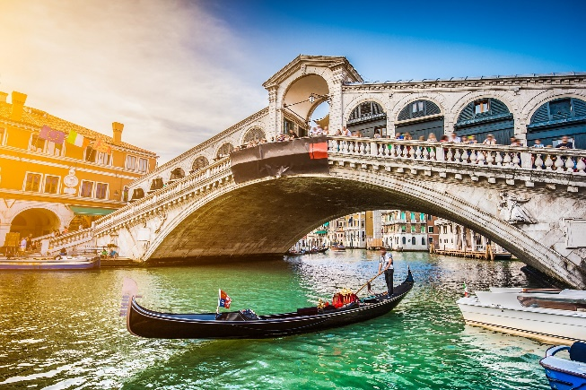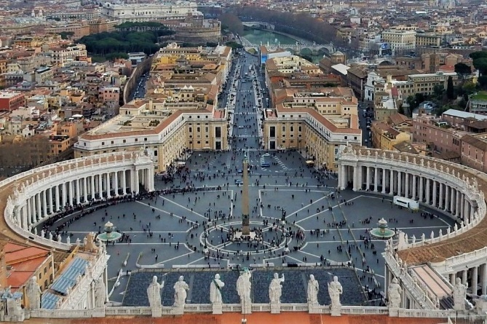

**I.Introduce:**

Travel around Europe

A trip to Europe, you will be thrilled by the mysterious beauty, diversity of buildings that are both ancient and modern and add admiration to the talented people who created them.

A journey - four destinations: Italy - France - Switzerland - Vatican (10 days | 9 nights) will take visitors to the most popular destinations in Europe. Coming to Paris fashion capital, the heart of Europe - Geneve tourist mecca, leaning tower of Pisa, Vatican ....



Highlights:

• Supporting Visa procedures for professional and dedicated customers, the highest visa rate up to 99%

• Experience the world's best 4-star international airline: Turkey Airway (Hanoi - Paris // Rome - Hanoi) 30 kg checked baggage + 7 kg cabin baggage

• 4 star hotel system of international standards in European countries

• Diverse meals according to the program at Vietnamese, Asian and European high-class restaurants

• A complete tour of European tangible, intangible and natural cultural heritages

• Explore Rome airport, Italy airport with many of the most duty free goods and shopping places in the world

• Professional guide, all the way from Vietnam to guide visitors throughout the process in Europe

• Travel insurance with the highest level of responsibility: 50,000 USD

• The most attractive gift: Power plug, travel cap

• Lunar New Year gifts

**II.** **INCLUDED AND TERMS:**

Travel around Europe

A trip to Europe, you will be thrilled by the mysterious beauty, diversity of buildings that are both ancient and modern and add admiration to the talented people who created them.

A journey - four destinations: France - Switzerland - Italy - Vatican (10 days | 9 nights) will take visitors to the most popular destinations in Europe. Coming to Paris fashion capital, the heart of Europe - Geneve tourist mecca, leaning tower of Pisa, Vatican ...



Highlights:

• Supporting Visa procedures for professional and dedicated customers, the highest visa rate up to 99%

• Experience the world's best 4-star international airline: Turkey Airway (Hanoi - Paris // Rome - Hanoi) 30 kg checked baggage + 7 kg cabin baggage

• 4 star hotel system of international standards in European countries

• Diverse meals according to the program at Vietnamese, Asian and European high-class restaurants

• A complete tour of European tangible, intangible and natural cultural heritages

• Explore Rome airport, Italy airport with many of the most duty free goods and shopping places in the world

• Professional guide, all the way from Vietnam to guide visitors throughout the process in Europe

• Travel insurance with the highest level of responsibility: 50,000 USD

• The most attractive gift: Power plug, travel cap

• Lunar New Year gifts